Chemistry 141 Name

Dr. Cary Willard

Exam 2b October 21, 2008

Multiple Choice (26 points)

Page 1 (19 points)

Page 2 (14 points)

Page 3 (19 points)

Page 4 (15 points)

Page 5 (18 points)

Total (111 points)

Percent (100 %)

All work must be shown to receive credit. Give all answers to the correct number of significant figures

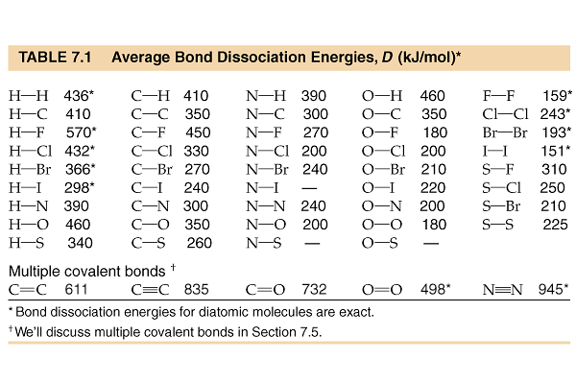

Chemistry Formulas and Constants

Kinetic energy = ½ mv2

w = -PΔV

Ptotal = P1+P2+P3+…

u = (3RT/MW)½

PV = nRT

Rate ∝ (MW)-½

P1=X1*Ptotal

C = q/ΔT

Ptotal = P1 + P2 + P3 + …

M = mol/L

K = oC + 273.16

Xi = moli/ moltotal



C = q/ΔT

E = mc2

M1V1 = M2V2

Ptotal = P1 + P2 + P3 + …

E = q + w

1 kcal = 4.184 kJ

NA = 6.02 x 1023 /mol

R = 0.0821 L atm/mol K = 62.4 L torr/mol K

Standard Temperature and Pressure = 0oC and 1 atm

760 torr = 760 mm Hg = 1.00 atm = 101 kPa = 14.6 psi = 30 in Hg



Multiple Choice. (26 points)

Choose the one alternative that best completes the statement or answers the question.

1. The nutritional calorie (abbreviated Cal) is equal to
   1. 1 kcal
   2. 4.184 J
   3. 4.184 cal
   4. 1 mcal
2. For most chemical reactions
   1. Δ *E* is much larger than Δ *H*.
   2. Δ *H* is equal to Δ *E*.
   3. Δ *H* is much larger than Δ *E*.
   4. the difference between Δ *H* and Δ *E* is very small.
3. Water has an unusually high
   1. heat of formation
   2. heat of combustion
   3. bond dissociation energy
   4. specific heat
4. The values of Δ *H°f* for the three states of benzene are approximately -22 kcal/mol, -11 kcal/mol, and 20kcal/mol. Which is the value for solid benzene?
   1. 20 kcal/mol
   2. −11 kcal/mol
   3. −22 kcal/mol
   4. cannot be determined without additional information
5. Which equation represents the reaction whose Δ *H*, represents the standard enthalpy of formation of CHCl3(*l*) at 25oC? (*i.e.*, for which is Δ *H* = Δ *Hof* of CHCl3)
   1. C(*s*) + H(*g*) + 3 Cl(*g*) 🡪 CHCl3(*l*)
   2. C(*s*) + ½ H2(*g*) + 3/2 Cl2(*g*) 🡪 CHCl3(*l*)
   3. CHCl3(*l*) 🡪 C(*s*) + H(*g*) + 3 Cl(*g*)
   4. 2 C(*s*) + H2(*g*) + 3 Cl2(*g*) 🡪 2 CHCl3(*l*)
6. Which of the following instruments directly measures the pressure of a gas?
   1. barometer
   2. polarimeter
   3. gas chromatograph
   4. spectrometer
   5. manometer
7. Suppose you needed to closely monitor small changes in pressure inside a container using an open end manometer. For the best accuracy, the substance in the manometer should
   1. be mercury
   2. be a solid
   3. have a low density
   4. have a high density
   5. be environmentally safe
8. Which one of the following gases will have the **lowest** rate of effusion?
   1. SO3
   2. SF4
   3. S2O5
   4. SCl4
9. Some assumptions from the kinetic molecular theory are listed below. Which one is most frequently cited to explain compressibility of a gas?
   1. A gas consists of tiny particles moving in random straight line motion.
   2. The average kinetic energy of gas particles is proportional to the Kelvin temperature.
   3. Collisions of gas particles are elastic and total kinetic energy of the gas is constant.
   4. The volume of the particles is negligible compared to the volume of the gas.
10. You are given two flasks of equal volume. One contains H2 at 0oC and 1 atm while the other contains CO2 at 0oC and 2 atm. Which of the following quantities will be the same for both flasks?
    1. average molecular kinetic energy
    2. average molecular speed
    3. number of molecules present
    4. density
    5. impossible to determine with the data given
11. A process by which gas molecules escape through a tiny hole in a membrane into a vacuum without collisions is called
    1. diffusion
    2. effusion
    3. sublimation
    4. Boyle's law
    5. compressibility

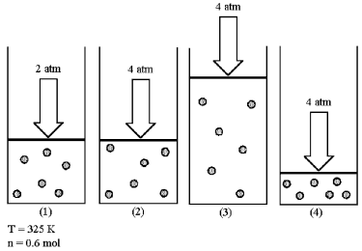

1. Assume that you have a sample of gas in a cylinder with a moveable piston, as shown in diagram (1). The initial pressure, number of moles, and temperature of the gas are noted on the diagram.

Which diagram (2)-(4) most closely represents the result of doubling the pressure while keeping the temperature and number of moles of gas constant?

* 1. diagram (2)
  2. diagram (3)
  3. diagram (4)
  4. none of them
  5. impossible to determine

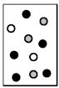

1. In the diagram to the right, helium atoms are represented by unshaded spheres, neon atoms by gray spheres, and argon atoms by black spheres.

If the total pressure in the container is 900 mmHg, what is the partial pressure of helium?

* 1. 450 mm Hg
  2. 270 mm Hg
  3. 90 mm Hg
  4. 180 mm Hg

Problems (70 points)

1. (4 points) What is the change in internal energy (ΔE) of a system that gives off 754 J of heat and has 561 J of work done on it?
2. (10 points) A 0.700 gram sample of C(graphite) was burned in a calorimeter with excess oxygen to determine the heat of formation of CO2(g). The temperature of the calorimeter increased from 25.00 to 30.56oC. The heat capacity of the calorimeter is 4.13 kJ/oC.
   1. Write the reaction corresponding to the heat of formation for CO2(g).
   2. What is the q of the reaction in J/g C(graphite) consumed?
   3. Calculate the heat of formation for CO2(g) using the data above?
3. (5 points) At the molecular level, how does hot water differ from cold water?
4. (8 points) Given the reaction

3 Fe2O3(s) + CO(g) 🡪 2 Fe3O4(s) + CO2(g) ΔH = −46 kJ

determine the ΔH for the following reactions

* 1. 4 Fe2O3(s) + 4/3 CO(g) 🡪 8/3 Fe3O4(s) + 4/3 CO2(g)
  2. 6 Fe3O4(s) + 3 CO2(g) 🡪 9 Fe2O3(s) + 3 CO(g)

1. (6 points) Both acetylene (C2H2) and ethylene (C2H4) yield ethane (C2H6) on hydrogenation, according to the following reactions:

C2H2(g) + 2 H2(g) 🡪 C2H6(g) ΔH = −311 kJ

C2H4(g) + H2(g) 🡪 C2H6(g) ΔH = −136 kJ

Calculate ΔHfor the formation of ethylene from acetylene and hydrogen, and write the equation for this process.

1. (6 points) Use the following equation and heats of formation to calculate the heat of formation of ZnS(s)

2 ZnS(s) + 3 O2(g) 🡪 2 ZnO(s) + 2 SO2(g) ΔH = −878.2 kJ

|  |  |
| --- | --- |
| substance | ΔHfo (kJ/mol) |
| ZnO(s) | −348.3 |
| SO2(g) | −296.8 |
| SO3(g) | −395.7 |

1. (8 points) Use bond energies to estimate the ΔH for the following reaction



1. (5 points) Aluminum metal reacts with chlorine with a spectacular display of sparks.

2 Al(s) + 3 Cl2(g) 🡪 2 AlCl3(s) ΔHo = −1408.4 kJ

How much heat (in kJ) is absorbed or released on the reaction of 9.00 g of Al? Is the reaction endothermic or exothermic?

1. (10 pts) At elevated temperatures, sodium chlorate decomposes to produce sodium chloride and oxygen gas. A 0.563 g sample of impure sodium chlorate was heated until the production of oxygen ceased. The oxygen gas collected over water occupied 57.2 mL at a temperature of 22 oC and a pressure of 734 torr. Calculate the mass percent of NaClO3 in the original sample. ( At 22oC the vapor pressure of water is 19.38 torr.)

Moles O2 collected

Balanced Equation

Mass NaClO3 decomposed

Percent NaClO3

1. (5 points) Imagine that you have two identical flasks, one containing krypton and other containing argon. How can you tell which is which without opening them?
2. (6 points) A newly discovered gas has a density of 4.74 g/L at 23.0oC and 715 mm Hg. What is the molar mass of the gas?
3. (6 points) A gas in a 4.62 L container at 25oC and pressure 827 torr is transferred into a 3.00 L container at a pressure of 3.05 atm. What is the new temperature of the gas?
4. (6 points) A vacuum pump exhausts a heavy-walled 1.50-L round-bottomed flask to a pressure of 2.54 x 10-6torr. How many particles are present if the temperature is 273 K?